MasterChef
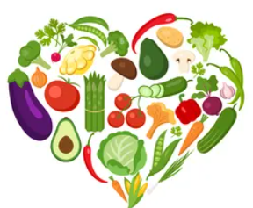
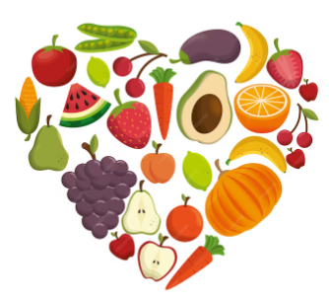
RADIONICE ZDRAVE HRANE
Učenici će biti podijeljeni u šest grupa.
Namirnice se nalaze u „trgovini“ na velikom stolu.
Začini su dostupni svim grupama, nalaze se na posebnom stolu.
Dvije grupe će raditi salate.
Dvije grupe će raditi zdravu tjesteninu.
Dvije grupe će praviti zdravi desert.

UPUTE ZA RAD – SALATE
Učenici će dobiti jednu osnovnu/zadanu namirnicu (salata ili kupus) i moći će još u „trgovini“ nabaviti pet drugih namirnica od kojih će praviti ukusnu salatu.

UPUTE ZA RAD – TJESTENINA
Učenici će za osnovnu/zadanu namirnicu dobiti jednu vrstu tjestenine, i moći će još u „trgovini“ nabaviti 5. drugih namirnica od kojih će praviti ukusnu tjesteninu.

UPUTE ZA RAD – DESERT
Učenici će dobiti jednu osnovnu/zadanu namirnicu (ananas ili kruške) i moći će još u „trgovini“ nabaviti 5. drugih namirnica od kojih će praviti ukusan desert.

IZRAČUNATI KALORIJSKU VRIJEDNOST SVIH OBROKA
- Treba izračunati koliko kcal ima vaš obrok, računajte sa 100 gr namirnica koje ste koristili u obroku.
MasterChef
HEALTHY FOOD WORKSHOPS

Goal of the workshop:
- make a healthy meal
- determine the vitamins present in the food
- determine the caloric value of 100g of prepared food

Steps:
- Students and teachers are divided in the six groups as a national teams .
- Each team will draw a card on which will be given a name of healthy meal they will prepare.

Two groups will be making salads.
Two groups will be making a healthy pasta dish.
Two groups will be making a healthy dessert.

3. The group gets one basic food item and choose five more according to their own preferences. Each group chooses the necessary groceries in the store.

(Groceries are going to be located at the so called ''store'', on a specific table.
Spices are available for all groups to use and will be found on table reserved specifically for spices.)

Working instructions- SALADS
Take basic (default) food item (salad or cabbage) and five other items from the ''store'' to make a delicious salad.
Working instructions- PASTA
Take basic (default) food item (a type of pasta) and five other items from the ''store'' to make a tasty pasta dish.
Working instructions- DESSERT
Take basic (default) food item (pineapple or pears) and five other items from the ''store'' to make a healthy, but luscious dessert.

- Name your dish

- Determine the 5 vitamins present in your dish using the attached table

- Determine the energy value of all meals using the attached table
You need to calculate how many kcal your meal has, calculate with 100g of food you used to make the meal.

- Fill out the attached sheet

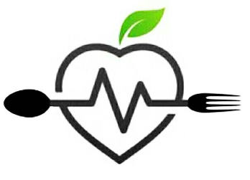
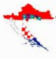

_____________________________________
(dish name)

Used food | Vitamins | kcal /100g
1.
2.
3.
4.
5.
6.

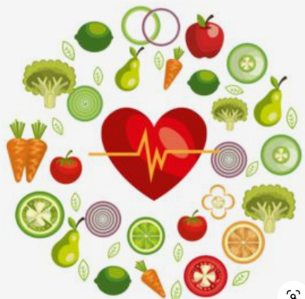

_____________________________________
(dish name)

Used food | Vitamins | kcal /100g
1.
2.
3.
4.
5.
6.

_____________________________________
(dish name)

Used food | Vitamins | kcal /100g
1.
2.
3.
4.
5.
6.

_____________________________________
(dish name)

Used food | Vitamins | kcal /100g
1.
2.
3.
4.
5.
6.

_____________________________________
(dish name)

Used food | Vitamins | kcal /100g
1.
2.
3.
4.
5.
6.

_____________________________________
(dish name)

Used food | Vitamins | kcal /100g
1.
2.
3.
4.
5.
6.

TABLE OF VITAMINS

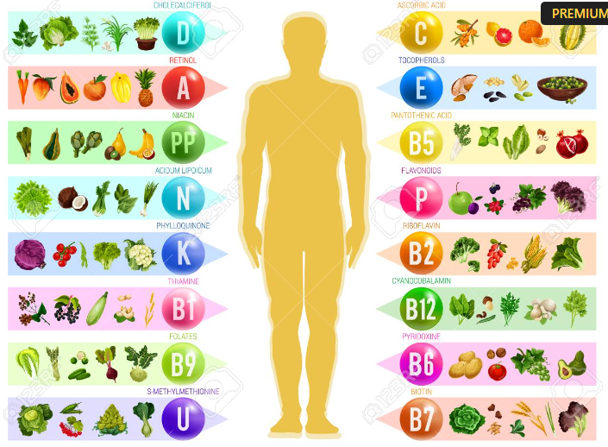

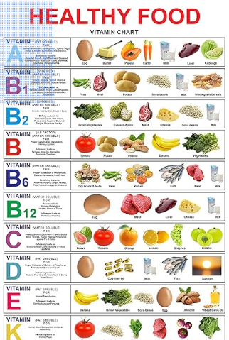
TABLE OF CALORIES IN FRUITS per 100g
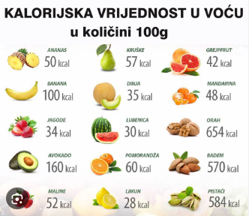

TABLE OF CALORIES IN VEGETABLES per 100g

